Private ASN

🌐 What Is Private ASN?
# Source: Chatgpt (GPT‑5 Mini) at [12/15/2025]
A Private ASN (Autonomous System Number) is an ASN reserved for use within private networks — not meant to be advertised over the public internet.
It allows organizations to use BGP (Border Gateway Protocol) internally or when connecting to an ISP that handles internet routing on their behalf.

🧠 Simple Definition:
# Source: Chatgpt (GPT‑5 Mini) at [12/15/2025]
A Private ASN is like a private IP address — used inside your network or between your network and your ISP, but not globally visible.

🔢 Private ASN Ranges
# Source: Chatgpt (GPT‑5 Mini) at [12/15/2025]
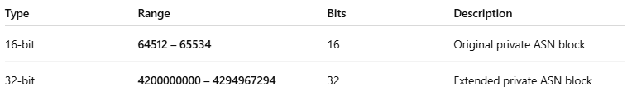

Type | Range | Bits | Description
16-bit | 64512 – 65534 | 16 | Original private ASN block
32-bit | 4200000000 – 4294967294 | 32 | Extended private ASN block
65535 and 4294967295 are reserved, not usable.

📦 Example Use Case
# Source: Chatgpt (GPT‑5 Mini) at [12/15/2025]
A company with ASN 64513 connects to two ISPs using BGP but does not need a public ASN. The ISPs assign public ASNs and strip the private ASN before advertising to the global internet.

🛠 Where Are Private ASNs Used?
# Source: Chatgpt (GPT‑5 Mini) at [12/15/2025]
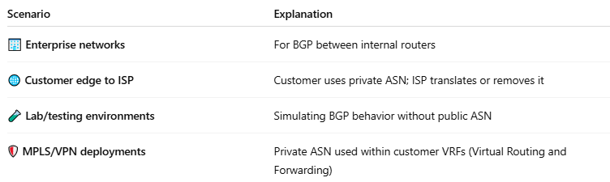

Scenario | Explanation
🏢 Enterprise networks | For BGP between internal routers
🌐 Customer edge to ISP | Customer uses private ASN; ISP translates or removes it
🧪 Lab/testing environments | Simulating BGP behavior without public ASN
🛡️ MPLS/VPN deployments | Private ASN used within customer VRFs (Virtual Routing and Forwarding)

🚫 Can You Advertise Private ASNs on the Internet?
# Source: Chatgpt (GPT‑5 Mini) at [12/15/2025]
No. Public internet routers will reject BGP updates that contain private ASNs — unless the ASN is removed or replaced using ASN translation by your ISP.

✅ Summary
# Source: Chatgpt (GPT‑5 Mini) at [12/15/2025]
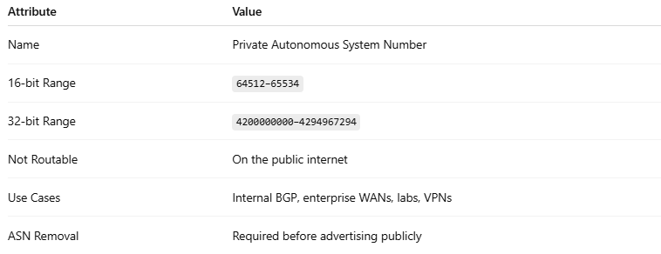

Attribute | Value
Name | Private Autonomous System Number
16-bit Range | 64512–65534
32-bit Range | 4200000000–4294967294
Not Routable | On the public internet
Use Cases | Internal BGP, enterprise WANs, labs, VPNs
ASN Removal | Required before advertising publicly

